Experiment No 10
Roll No:24141030 Lab: PL-II

Theory:
1. Introduction to GUI Programming
GUI (Graphical User Interface) programming allows users to interact with programs using graphical elements like windows, buttons, text fields, and menus instead of command-line interfaces. Python offers several GUI frameworks, with Tkinter being the standard built-in library.

2. Tkinter Overview
Tkinter is Python's standard GUI library. It provides a fast and easy way to create GUI applications. Tkinter is cross-platform and comes pre-installed with Python.
Import Tkinter:
import tkinter as tk
from tkinter import *

3. Tkinter Widgets
Widget | Description
Label | Displays text or image
Button | Clickable button
Entry | Single-line text input
Text | Multi-line text input
Frame | Container for other widgets
Canvas | Drawing area
Checkbutton | Checkbox
Radiobutton | Radio button
Listbox | List of items

4. Tkinter Geometry Managers
Manager | Description
pack() | Packs widgets in blocks
grid() | Places widgets in grid (rows/columns)
place() | Places widgets at specific coordinates

5. Common Tkinter Methods
Method | Description
tk.Tk() | Creates main window
mainloop() | Starts event loop
destroy() | Closes window
title() | Sets window title
geometry() | Sets window size
config() | Configures widget properties

7. Matplotlib Overview
Matplotlib is a comprehensive library for creating static, animated, and interactive visualizations in Python.
8. Types of Plots
Plot Type | Use Case
Line Plot | Trends over time
Bar Chart | Comparing categories
Histogram | Distribution of data
Pie Chart | Proportions/percentages
Scatter Plot | Relationship between variables
Box Plot | Statistical summary

Programs and Code
1. Program to create a simple GUI window using Tkinter
import tkinter as tk
root = tk.Tk()
root.title("My First GUI Window")
root.geometry("400x300")
root.configure(bg="lightblue")
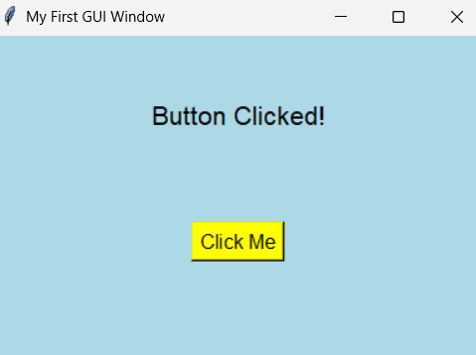
label = tk.Label(root, text="Welcome to GUI Programming!",
font=("Arial", 16), bg="lightblue")
label.pack(pady=50)
def on_click():
label.config(text="Button Clicked!")
button = tk.Button(root, text="Click Me", command=on_click,
font=("Arial", 12), bg="yellow")
button.pack(pady=20)
root.mainloop()

2. Program to create a GUI calculator
import tkinter as tk
def click(button):
current = entry.get()
if button == "=":
try:
result = eval(current)
entry.delete(0, tk.END)
entry.insert(tk.END, str(result))
except:
entry.delete(0, tk.END)
entry.insert(tk.END, "Error")
elif button == "C":
entry.delete(0, tk.END)
else:
entry.insert(tk.END, button)
root = tk.Tk()
root.title("Calculator")
root.geometry("300x400")
root.configure(bg="black")
entry = tk.Entry(root, font=("Arial", 20), justify="right", bg="white")
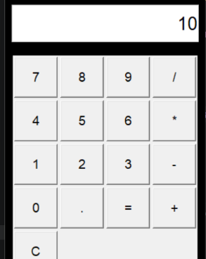
entry.pack(fill=tk.BOTH, padx=10, pady=10, ipady=10)
buttons = [
['7', '8', '9', '/'],
['4', '5', '6', '*'],
['1', '2', '3', '-'],
['0', '.', '=', '+'],
['C']]

frame = tk.Frame(root)
frame.pack(padx=10, pady=10)
for i, row in enumerate(buttons):
for j, btn in enumerate(row):
b = tk.Button(frame, text=btn, font=("Arial", 14), width=5, height=2,
command=lambda x=btn: click(x))
b.grid(row=i, column=j, padx=2, pady=2)
root.mainloop()

3. Program to create GUI for student information form
import tkinter as tk
from tkinter import messagebox
def submit_form():
name = entry_name.get()
roll = entry_roll.get()
branch = branch_var.get()
year = year_var.get()
if not name or not roll:
messagebox.showerror("Error", "Name and Roll Number are required")
return
messagebox.showinfo("Success", f"Student {name} registered successfully!")
entry_name.delete(0, tk.END)
entry_roll.delete(0, tk.END)
root = tk.Tk()
root.title("Student Information Form")
root.geometry("400x350")
root.configure(bg="#f0f0f0")
title = tk.Label(root, text="STUDENT REGISTRATION FORM",
font=("Arial", 14, "bold"), bg="#f0f0f0")
title.pack(pady=10)
frame = tk.Frame(root, bg="#f0f0f0")
frame.pack(pady=20)
tk.Label(frame, text="Name:", font=("Arial", 11), bg="#f0f0f0").grid(row=0, column=0, pady=5, sticky="w")
entry_name = tk.Entry(frame, font=("Arial", 11), width=25)
entry_name.grid(row=0, column=1, pady=5)
tk.Label(frame, text="Roll No:", font=("Arial", 11), bg="#f0f0f0").grid(row=1, column=0, pady=5, sticky="w")
entry_roll = tk.Entry(frame, font=("Arial", 11), width=25)
entry_roll.grid(row=1, column=1, pady=5)
tk.Label(frame, text="Branch:", font=("Arial", 11), bg="#f0f0f0").grid(row=2, column=0, pady=5, sticky="w")
branch_var = tk.StringVar(value="CS")
branches = [("Computer Science", "CS"), ("Information Technology", "IT"),
("Electronics", "EC"), ("Mechanical", "ME")]
for i, (text, value) in enumerate(branches):
tk.Radiobutton(frame, text=text, variable=branch_var, value=value,
bg="#f0f0f0").grid(row=2, column=i+1, pady=5, sticky="w")
tk.Label(frame, text="Year:", font=("Arial", 11), bg="#f0f0f0").grid(row=3, column=0, pady=5, sticky="w")
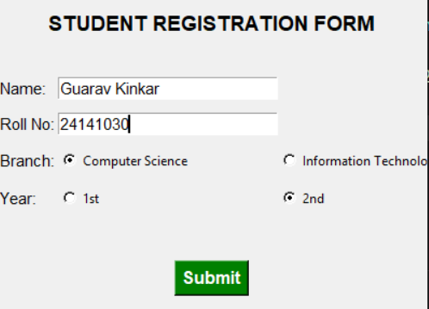
year_var = tk.StringVar(value="1")
years = ["1st", "2nd", "3rd", "4th"]
for i, year in enumerate(years):
tk.Radiobutton(frame, text=year, variable=year_var, value=year,
bg="#f0f0f0").grid(row=3, column=i+1, pady=5, sticky="w")
submit_btn = tk.Button(root, text="Submit", font=("Arial", 12, "bold"),
bg="green", fg="white", command=submit_form)
submit_btn.pack(pady=20)

root.mainloop()

4. Program to draw line plot using matplotlib
import matplotlib.pyplot as plt
import numpy as np
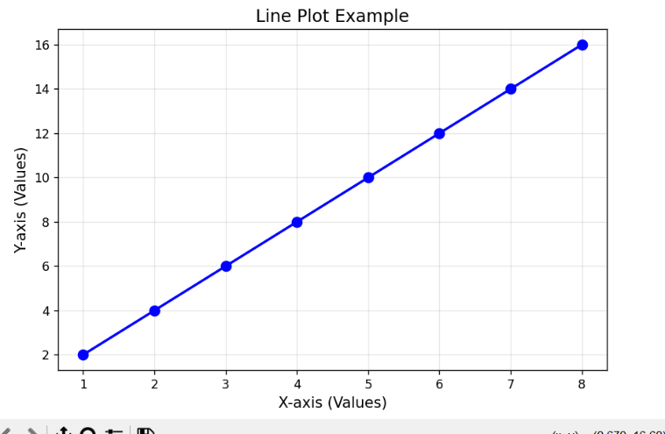
x = np.array([1, 2, 3, 4, 5, 6, 7, 8])
y = np.array([2, 4, 6, 8, 10, 12, 14, 16])
plt.figure(figsize=(8, 5))
plt.plot(x, y, marker='o', linestyle='-', color='b', linewidth=2, markersize=8)
plt.title("Line Plot Example", fontsize=14)
plt.xlabel("X-axis (Values)", fontsize=12)
plt.ylabel("Y-axis (Values)", fontsize=12)
plt.grid(True, alpha=0.3)
plt.show()

5. Program to draw bar chart
import matplotlib.pyplot as plt
subjects = ['Python', 'Java', 'C++', 'JavaScript', 'HTML/CSS']
scores = [88, 75, 82, 90, 85]
colors = ['skyblue', 'lightgreen', 'lightcoral', 'gold', 'plum']
plt.figure(figsize=(10, 6))
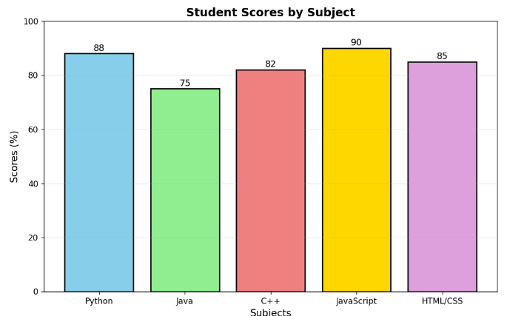
plt.bar(subjects, scores, color=colors, edgecolor='black', linewidth=1.5)
plt.title("Student Scores by Subject", fontsize=14, fontweight='bold')
plt.xlabel("Subjects", fontsize=12)
plt.ylabel("Scores (%)", fontsize=12)
plt.ylim(0, 100)
for i, score in enumerate(scores):
plt.text(i, score + 1, str(score), ha='center', fontsize=11)
plt.grid(axis='y', alpha=0.3)
plt.show()

6. Program to draw histogram
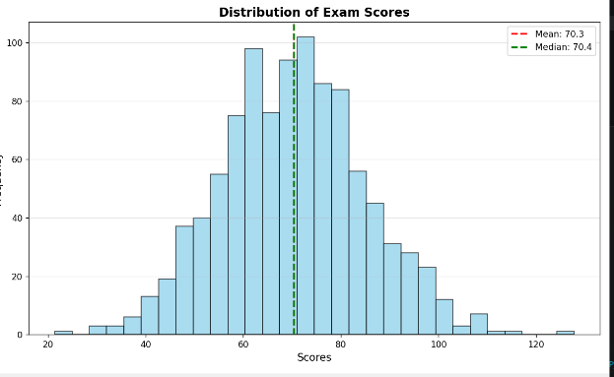
import matplotlib.pyplot as plt
import numpy as np
np.random.seed(42)
data = np.random.normal(loc=70, scale=15, size=1000) # Mean=70, Std=15
plt.figure(figsize=(10, 6))
plt.hist(data, bins=30, color='skyblue', edgecolor='black', alpha=0.7)
plt.title("Distribution of Exam Scores", fontsize=14, fontweight='bold')
plt.xlabel("Scores", fontsize=12)
plt.ylabel("Frequency", fontsize=12)
plt.grid(axis='y', alpha=0.3)
plt.axvline(data.mean(), color='red', linestyle='dashed', linewidth=2, label=f'Mean: {data.mean():.1f}')
plt.axvline(data.median(), color='green', linestyle='dashed', linewidth=2, label=f'Median: {data.median():.1f}')
plt.legend()
plt.show()

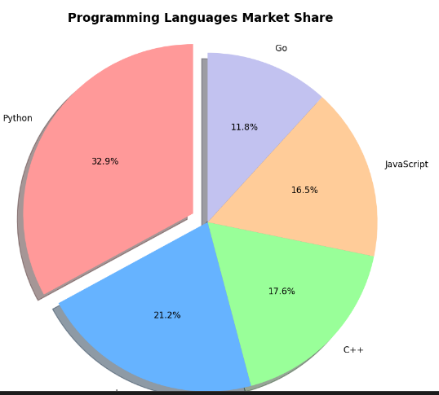
7. Program to draw pie chart
import matplotlib.pyplot as plt
languages = ['Python', 'Java', 'C++', 'JavaScript', 'Go']
market_share = [28, 18, 15, 14, 10]
colors = ['#ff9999', '#66b3ff', '#99ff99', '#ffcc99', '#c2c2f0']
explode = (0.1, 0, 0, 0, 0) # Explode first slice
plt.figure(figsize=(8, 8))
plt.pie(market_share, labels=languages, colors=colors, explode=explode,
autopct='%1.1f%%', startangle=90, shadow=True)
plt.title("Programming Languages Market Share", fontsize=14, fontweight='bold')
plt.axis('equal') # Equal aspect ratio ensures pie is circular
plt.show()
8. Program to draw box-and-whisker plot
import matplotlib.pyplot as plt
import numpy as np
np.random.seed(42)
data_group1 = np.random.normal(50, 10, 100)
data_group2 = np.random.normal(60, 12, 100)
data_group3 = np.random.normal(45, 8, 100)
data_group4 = np.random.normal(70, 15, 100)
data = [data_group1, data_group2, data_group3, data_group4]
labels = ['Group A', 'Group B', 'Group C', 'Group D']
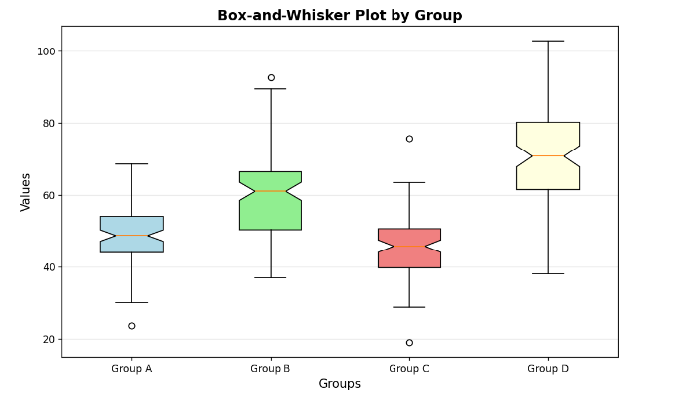
plt.figure(figsize=(10, 6))
bp = plt.boxplot(data, labels=labels, patch_artist=True, notch=True)
colors = ['lightblue', 'lightgreen', 'lightcoral', 'lightyellow']
for patch, color in zip(bp['boxes'], colors):
patch.set_facecolor(color)
plt.title("Box-and-Whisker Plot by Group", fontsize=14, fontweight='bold')
plt.xlabel("Groups", fontsize=12)
plt.ylabel("Values", fontsize=12)
plt.grid(axis='y', alpha=0.3)
plt.show()

9. Program to customize plots using labels and legends
import matplotlib.pyplot as plt
import numpy as np
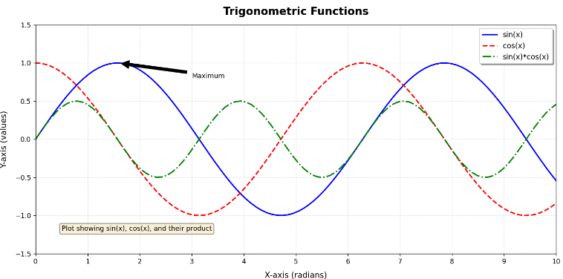
x = np.linspace(0, 10, 100)
y1 = np.sin(x)
y2 = np.cos(x)
y3 = np.sin(x) * np.cos(x)
plt.figure(figsize=(12, 6))
plt.plot(x, y1, 'b-', linewidth=2, label='sin(x)')
plt.plot(x, y2, 'r--', linewidth=2, label='cos(x)')
plt.plot(x, y3, 'g-.', linewidth=2, label='sin(x)*cos(x)')
plt.title("Trigonometric Functions", fontsize=16, fontweight='bold', pad=15)
plt.xlabel("X-axis (radians)", fontsize=12, labelpad=10)
plt.ylabel("Y-axis (values)", fontsize=12, labelpad=10)
plt.legend(loc='upper right', fontsize=11, frameon=True, shadow=True, fancybox=True)
plt.grid(True, alpha=0.3, linestyle='--')
plt.xlim(0, 10)
plt.ylim(-1.5, 1.5)
plt.xticks(np.arange(0, 11, 1))
plt.yticks(np.arange(-1.5, 1.6, 0.5))
plt.annotate('Maximum', xy=(np.pi/2, 1), xytext=(3, 0.8),
arrowprops=dict(facecolor='black', shrink=0.05))
props = dict(boxstyle='round', facecolor='wheat', alpha=0.5)
plt.text(0.5, -1.2, 'Plot showing sin(x), cos(x), and their product',
fontsize=10, bbox=props)
plt.tight_layout()
plt.show()
10. Program to read data from file and plot graph
import matplotlib.pyplot as plt
import numpy as np
def create_sample_data():
data = """Year,Sales,Profit
2020,100,20
2021,150,35
2022,200,50
2023,180,45
2024,250,70"""
with open('sales_data.csv', 'w') as f:
f.write(data)
print("Sample data file 'sales_data.csv' created")
def plot_from_file():
try:
years = []
sales = []
profits = []
with open('sales_data.csv', 'r') as f:
lines = f.readlines()
header = lines[0].strip().split(',')
for line in lines[1:]:
data = line.strip().split(',')
years.append(int(data[0]))
sales.append(float(data[1]))
profits.append(float(data[2]))
fig, (ax1, ax2) = plt.subplots(1, 2, figsize=(12, 5))
ax1.plot(years, sales, 'b-o', linewidth=2, markersize=8, label='Sales')
ax1.set_title('Sales Trend', fontsize=12, fontweight='bold')
ax1.set_xlabel('Year')
ax1.set_ylabel('Sales (in $K)')
ax1.grid(True, alpha=0.3)
ax1.legend()
ax2.bar(years, profits, color='green', alpha=0.7, edgecolor='black', label='Profit')
ax2.set_title('Profit by Year', fontsize=12, fontweight='bold')
ax2.set_xlabel('Year')
ax2.set_ylabel('Profit (in $K)')
ax2.grid(axis='y', alpha=0.3)
ax2.legend()
for i, (year, profit) in enumerate(zip(years, profits)):
ax2.text(year, profit + 2, f'{profit}', ha='center', fontsize=9)
plt.suptitle('Company Performance Analysis', fontsize=14, fontweight='bold')
plt.tight_layout()
plt.show()
print("\n=== Data Summary ===")
print(f"Years: {years}")
print(f"Sales: {sales}")
print(f"Profits: {profits}")
print(f"Average Sales: ${np.mean(sales):.2f}K")
print(f"Average Profit: ${np.mean(profits):.2f}K")
print(f"Total Sales: ${sum(sales)}K")
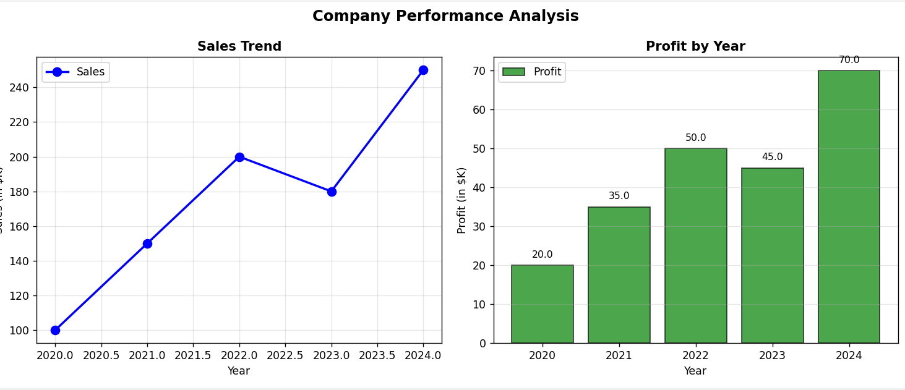
print(f"Total Profit: ${sum(profits)}K")
except FileNotFoundError:
print("Data file not found. Creating sample data...")
create_sample_data()
plot_from_file()
except Exception as e:
print(f"Error: {e}")
plot_from_file()

Conclusion
In this experiment, we studied GUI programming using Tkinter (creating windows, labels, buttons, entry fields, forms, and a calculator) and data visualization using Matplotlib (line plots, bar charts, histograms, pie charts, box plots, and customized plots with labels and legends). These skills are essential for building interactive applications and visualizing data effectively.

